**Dashboard Report for ShopNest Store**

**Table of Contents**

1. Introduction
2. Rating Distribution
3. Top 10 and Bottom 18 Most Popular Product Categories
4. Total Number of Active Sellers by Yearly and Monthly
5. Most Common Payment Methods
6. Product Category-wise Profit Margin
7. Monthly Payments Made by Customers Using Credit Cards
8. Sellers Categorized by City (Excluding Cities Starting with S and B)
9. Conclusion

**1. Introduction**

The ShopNest Store Capstone Dashboard provides a comprehensive analysis of key business metrics for the leading e-commerce department store in Portugal. This report documents the dashboard's design and the insights derived from the data analysis.

**2. Rating Distribution**

**Question Statement:**

Identify the rating distribution in the ShopNest dataset, showcasing ratings categorized as Excellent, Very Good, Good, Bad, and Very Bad, along with corresponding orders.

**Visualization:**

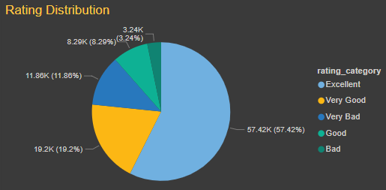

**Explanation:**

This pie chart visualizes the distribution of ratings given by customers. The ratings are categorized as Excellent (5 stars), Very Good (4 stars), Good (3 stars), Bad (2 stars), and Very Bad (1 star). The chart shows the count of review_ids for each rating category, providing insights into overall customer satisfaction.

**3. Top 10 and Bottom 18 Most Popular Product Categories**

**Question Statement:**

What are the top 10 and bottom 18 most popular product categories in the ShopNest dataset? Please list them based on the number of orders.

**Visualization:**

* Top 10 Most Popular Product Categories:

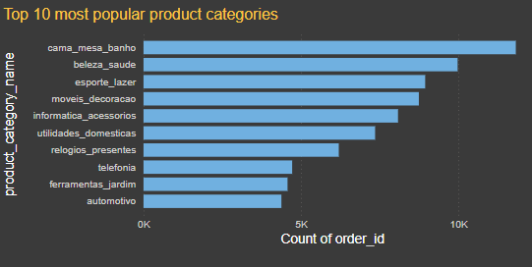

* Bottom 18 Most Popular Product Categories:

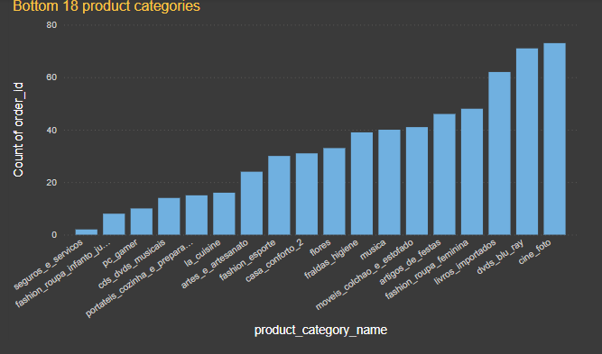

**Explanation:**

These stacked bar chart and stacked column chart display the top 10 and bottom 18 product categories based on the number of orders. This visualization helps identify which product categories are the most and least popular among customers, aiding in inventory and marketing strategies.

**4. Total Number of Active Sellers by Yearly and Monthly**

**Question Statement:**

List the total number of active sellers by yearly and monthly.

**Visualization:**

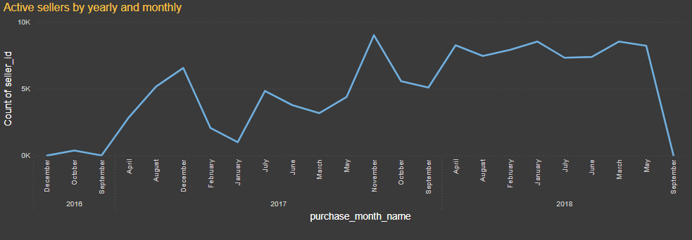

**Explanation:**

The line chart shows the total number of active sellers over time, segmented by year and month. This visualization highlights trends in seller engagement and activity on the ShopNest platform.

**5. Most Common Payment Methods**

**Question Statement:**

Which payment methods are most commonly used by ShopNest customers?

**Visualization:**

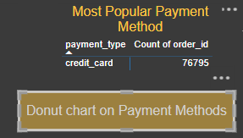 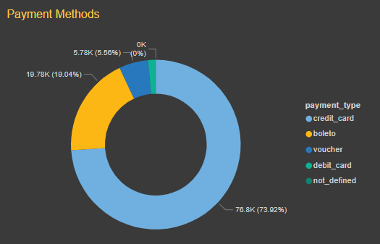

**Explanation:**

Dashboard displays most used payment method. Also, a button with navigation action set to a page that shows donut chart which illustrates the distribution of different payment methods used by customers. It provides insights into customer preferences for payment options, which can influence ShopNest's payment processing strategies.

**6. Product Category-wise Profit Margin**

**Question Statement:**

Identify the product category-wise profit margin using the formula: (Payment value - price + Freight_value) / payment_value * 100 (Rounded to two decimal points).

**Visualization:**



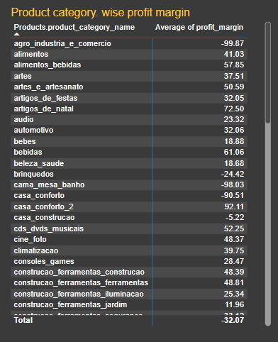

**Explanation:**

Dashboard displays a button with navigation action set to a page which shows the average profit margin for each product category in a matrix chart. This visualization helps identify which product categories are the most profitable, guiding pricing and sales strategies.

**7. Monthly Payments Made by Customers Using Credit Cards**

**Question Statement:**

Determine the monthly payments made by customers using credit cards.

**Visualization:**



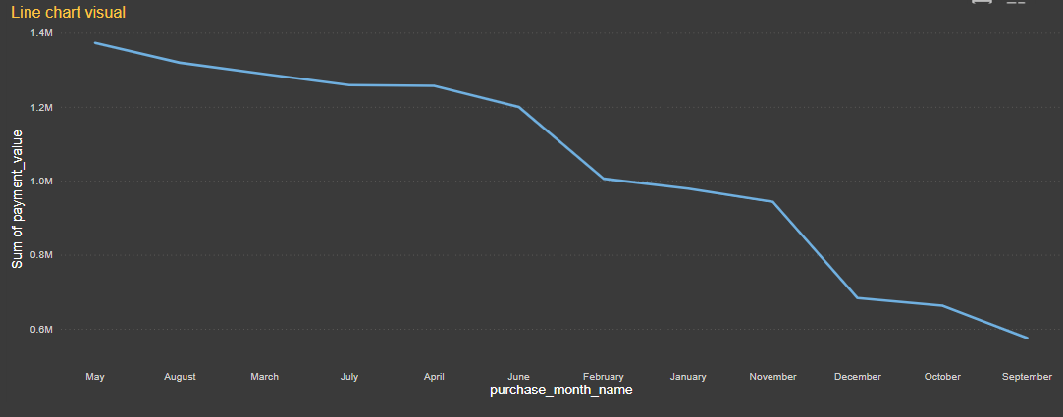

**Explanation:**

Dashboard displays a button with navigation action set to a page that shows a line chart which visualizes the total monthly payments made by customers using credit cards. This helps in understanding payment trends and the financial behaviour of customers over time.

**8. Sellers Categorized by City (Excluding Cities Starting with S and B)**

**Question Statement:**

Identify sellers categorized by city, excluding cities starting with the letters S and B.

**Visualization:**



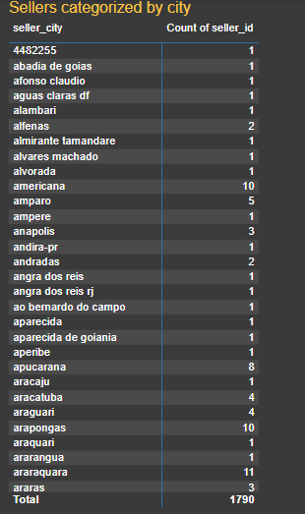

**Explanation:**

Dashboard shows a button with navigation action set to a page that shows matrix chart of distribution of sellers by city, excluding those starting with S and B. It provides geographical insights into where most sellers are located, which can assist in regional marketing and logistics planning.

**9. Conclusion:**

The ShopNest Store Capstone Dashboard provides valuable insights into various aspects of the business, from customer satisfaction to seller engagement and payment methods. By leveraging these insights, ShopNest can make informed decisions to enhance its operations and customer experience.